Brenda's Ribbed Booties
Designed by Brenda Cole, New York

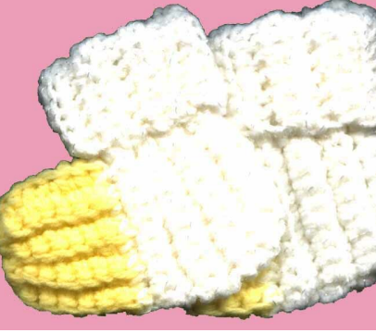

YARN / HOOK: Baby/Fingering weight yarn; Size F-I hook (size needed for gauge 4 sc/inch)
NOTE: Pattern is for newborn size; (preemie sizes in large, medium, and small are listed in parenthesis.)
TOE: Leave 8" tail of yarn at beginning of chain for stitching. Ch 10 (8, 6, 5). Sc in 2nd chain from hook and in each chain across, 9 sc (7, 5, 4). Ch 1, turn. Working in BACK loops only, sc 21 (20, 18, 16) rows of 9 (7, 5, 4). Break off yarn.
CUFF: Ch 12 (12, 10, 8) - attach at side of foot at end of last row, sc across edge. Ch 12 (12, 10, 8). Turn. Sc in 2nd chain from hook and in each chain across, working in BACK loops only of sc. Ch 1, turn. Make 12 (10, 8, 7) rows and leave tail at the end. (This piece will form the heel and ankle of the bootie)
FINISHING: You will have a T-shaped piece. Weave tail of yarn through the end stitches of the 'base' of the 'T' and gather to form toe. Fold in half, sew up the front of the bootie, finish off. Sew from back of cuff down to heel, finish off.
Fold cuff down.

